**Initial requirement statement:**

others make it, but the only we can sell it can make money from it

**Suitable license:**

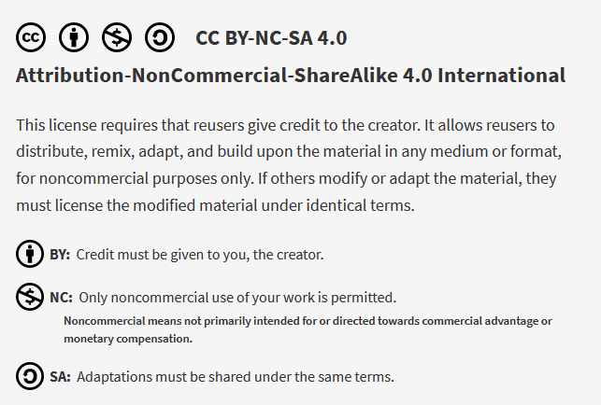

In order to “be compatible” with the Open Source Hardware certification the license can’t restrict the right for commercial use of the derivative work

|  |  |
| --- | --- |
|  | * Design files are publicly available * You can ask for Attribution * You can ask for Share alike * You can’t restrict the commercial use of derivative work Proof: [Definition (English) – Open Source Hardware Association (oshwa.org)](https://www.oshwa.org/definition/) |

|  |  |
| --- | --- |
|  | * Fits the requirement of exclusive right to sell the PCB * Not compatible with the Open source hardware certification |
|  | * Compatible with the Open source hardware certification |

The trick to embed the non commercial use into the license while still keeping the exclusive right to sell it is to use the Trademark



For example with Arduino: <https://www.arduino.cc/en/trademark>

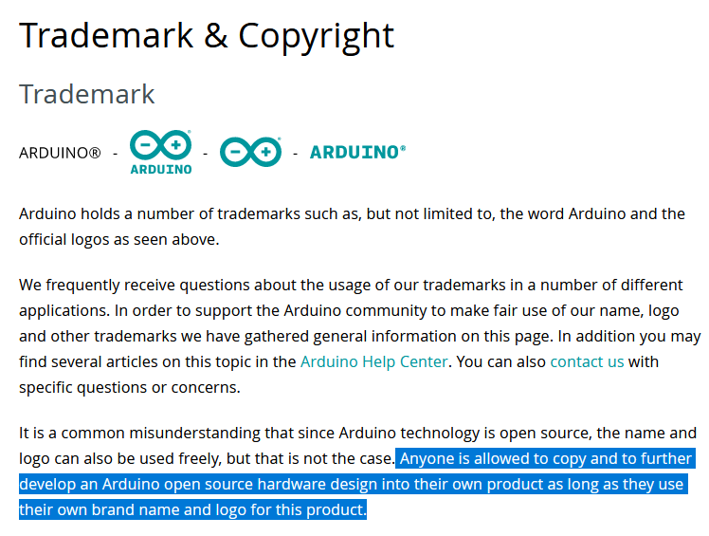

What licenses are used by some open hardware projects:

|  |  |
| --- | --- |
|  | Arduino  Adafruit |
|  | Sparkfun |
| Sources made available under no license | Flipper Zerro  Turris MOX |
| CERN Open Hardware License | Open Flexture Microscope |

